Artist Study: Natural Artist
Andy Goldsworthy

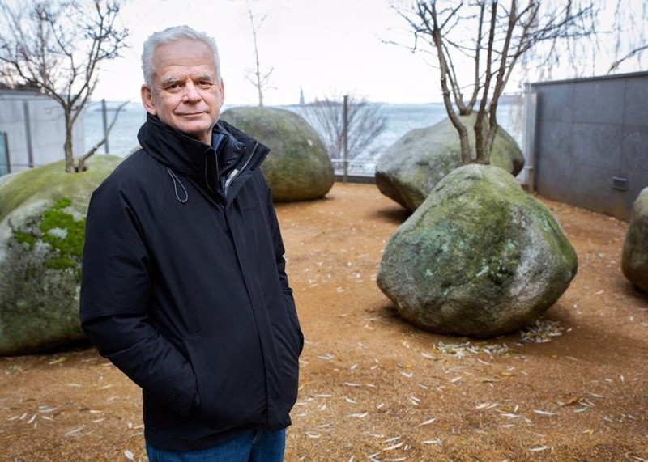

Andy Goldsworthy is a British artist known for his site-specific installations involving natural materials and the passage of time. Working as both sculptor and photographer, Goldsworthy crafts his installations out of rocks, ice, leaves, or branches, cognizant that the landscape will change, then carefully documents the natural art he calls collaborations with nature through photography.

Born on July 29, 1956 in Cheshire, United Kingdom, the artist spent his teenage years working as a farm laborer in rural England before going on to study art at Bradford College of Art and later Preston Polytechnic.
He later became associated with the Environmental Art movement alongside Richard Long and Chris Drury.

In 2001, Andy Goldsworthy Working with Time was released, showing the artist at work in nature and his process beforehand. A follow-up documentary, Leaning Into the Wind, was released in 2018. Goldworthy’s works are held in the collections of the Courtauld Institute of Art in London, the Storm King Art Center in Mountainville, NY, and the National Gallery of Art in Washington, D.C., among others. The artist currently lives and works in Dumfriesshire, United Kingdom.

The artist has stated, “It's not about art,” he has explained. “It's just about life and the need to understand that a lot of things in life do not last.”

•Vocabulary:
Photography, Environmental Issues, Andy Goldsworthy, Sketch, Documentary

•Essential questions:
Who or what is involved in building and destroying the environment?
How can you take responsibility for the environment?

•Scaffolding questions:
Are humans responsible for forest fires and oil spills and why?
Why is Andy Goldsworthy’s art important to share?
Why is the meaning behind Andy Goldsworthy’s art?

